 | 
COUNCIL ASSESSMENT REPORT
NORTHERN REGIONAL PLANNING PANEL

PANEL REFERENCE & DA NUMBER | PPSNTH-457 – BYRON – 10.2017.661.3
PROPOSAL | Section 4.56 to reduce 10 stages of the 13 stage subdivision, being Stages 1 – 10, to 4 stages, proposed Stages 1 – 4; and consequential amendments to conditions to reflect the new stage numbering.
ADDRESS | - Lot 1 DP 201626 – Ewingsdale Road Byron Bay  - Lot 2 DP 542178 – 394 Ewingsdale Road Byron Bay  - Lot 1 DP 780242 – 412 Ewingsdale Road Byron Bay  - Lot 2 DP 818403 – Melaleuca Drive Byron Bay  - Lot 1 DP 520063 – 364 Ewingsdale Road Byron Bay  - Lot 7020 DP 1113431 – Ewingsdale Road Byron Bay (swale drain)  - Lot 105 DP 1297628 – 288 Ewingsdale Road Byron Bay
APPLICANT | Stuart Murray
OWNER | - Gousse Holdings Pty Ltd  - Telicove Pty Ltd  - Mr DJ O’Connor & Mrs CF O’Connor  - Byron Shire Council (swale drain)  - Mr AR & Mrs JD Smith & Fletcher Project Developments Pty Ltd  - Byron Bay Industrial Pty Ltd
S4.56 LODGEMENT DATE | 29/07/2025
ORIGINAL DA DETERMINATION DATE | - 08/03/2022 - judgment of Site R & D Pty Ltd v Byron Shire Council [2022] NSWLEC 1121 published and DA 10.2017.661.1 approved.  - 21/04/2022 - Conditions of Consent filed for 10.2017.661.1  - 11/12/2024 – S4.56 10.2017.661.2 approved
APPLICATION TYPE | Modification Application under Section 4.56
REGIONALLY SIGNIFICANT CRITERIA | Section 2.19(1) and Section 2 of Schedule 6 of State Environmental Planning Policy (Planning Systems) 2021: General development over $30 million.
CIV | $40,000.000
CLAUSE 4.6 REQUESTS | Not applicable
KEY SEPP/LEP | Relevant Environmental Planning Instruments  - State Environmental Planning (Biodiversity and Conservation) 2021  - State Environmental Planning Policy (Planning Systems) 2021  - State Environmental Planning Policy (Resilience and Hazards) 2021  - State Environmental Planning Policy (Transport and Infrastructure) 2021  Local Environmental Plan  - Byron Local Environmental Plan 2014  Relevant Development Control Plan  - Byron Development Control Plan 2014
TOTAL & UNIQUE SUBMISSIONS KEY ISSUES IN SUBMISSIONS | 2 identical submissions  The issues raised relate to the original DA and are generally not relevant for the subject S4.56 Modification.
DOCUMENTS SUBMITTED FOR CONSIDERATION | - Statement of Environmental Effects  - Ecological statement of support  - Amended Subdivision Plans
SPECIAL INFRASTRUCTURE CONTRIBUTIONS (S7.24) | Not applicable
RECOMMENDATION | Approval
DRAFT CONDITIONS TO APPLICANT | Yes – copy of amended conditions sent to applicant
SCHEDULED MEETING DATE | 17 November 2025
PLAN VERSION
  15024-25C Sheet 2 | Subdivision Layout & Staging – Plan 2 | Abbott & Macro | 17.04.2025
  15024-25C Sheet 3 | Subdivision Layout & Staging – Plan 3 | Abbott & Macro | 17.04.2025
  15024-25C Sheet 4 | Proposed Community Title & Environmental Association Lots – Plan 4 | Abbott & Macro | 17.04.2025
  FIG – 201 Issue A | Erosion and Sediment Control Plan Modified Stage 1 | Stanhold Consulting Engineer, BTE Consulting | 4 March 2025
  FIG – 202 Issue A | Erosion and Sediment Control Plan Stage Modified 2 | Stanhold Consulting Engineer, BTE Consulting | 6 March 2025
  FIG – 203 Issue A | Erosion and Sediment Control Plan Stage Modified 3 | Stanhold Consulting Engineer, BTE Consulting | 6 March 2025
  FIG – 204 Issue A | Erosion and Sediment Control Plan Stage Modified 4 | Stanhold Consulting Engineer, BTE Consulting | 6 March 2025
  FIG – 100 Issue C | Overall Staging Plan | Stanhold Consulting Engineer, BTE Consulting | 14.05.25
  FIG – 101 Issue A | Staging Plan Stage 1 | Stanhold Consulting Engineer, BTE Consulting | 06.03.25
  FIG – 102 Issue A | Staging Plan Stage 2 | Stanhold Consulting Engineer, BTE Consulting | 06.03.25
  FIG – 103 Issue A | Staging Plan Stage 3 | Stanhold Consulting Engineer, BTE Consulting | 06.03.25
  FIG – 104 Issue A | Staging Plan Stage 4 | Stanhold Consulting Engineer, BTE Consulting | 06.03.25
PREPARED BY | Greg Yopp
DATE OF REPORT | 30 October 2025

EXECUTIVE SUMMARY

Development consent 10.2017.661.1 was issued on 8 March 2022 by the NSW Land and Environment Court to subdivide land in two separate areas within the West Byron Urban Release Area (WBURA) and permits the creation of one hundred and sixty two (162) lots and associated works over twelve (12) stages. The development location is known as ‘Site R&D’.

This Section 4.56 Modification seeks approval to amend development consent 10.2017.661.1 (as modified) to enable the reduction in the number of subdivision stages on the eastern precinct of the development site from ten (10) to four (4), as well as consequential amendments to consent conditions. Two other subdivision stages (Stages 11 and 12) are located in the western precinct of the site and are not involved in this modification application.

Justification for the proposed consolidation of staging arises from the need for cost efficiency and practical construction logistics. Consolidated staging will also reduce the time period associated with potential negative construction phase impacts for adjoining and nearby residents.

The application was lodged on 29/07/2025 and placed on public exhibition from 12/08/25 to 25/08/25.

A detailed consideration of the applicable environmental planning instruments was provided in the Commissioner’s Judgement on the original application (Site R and D Pty Ltd v Byron Shire Council [2022] NSWLEC 1121). The modification application does not raise any new issues in relation to the environmental planning instruments; proposed instruments; development control plans; planning agreements; and the regulations; applicable to the original development application, other than those listed within the body of the report.

Relevant State Environmental Planning Policies
The proposed amendments do not raise any specific issues under the relevant SEPPs which apply to the site including the SEPP (Biodiversity & Conservation) 2021, SEPP (Transport and Infrastructure) 2021 and SEPP (Resilience and Hazards) 2021.

In accordance with clause 4.8 of SEPP (Biodiversity & Conservation) 2021, the Byron Coast Comprehensive Koala Plan of Management (BCCKPoM) applies. The modification application does not seek to change the subdivision layout, extent of works, tree removal or environmental restoration works. As such, the proposal is consistent with the Byron Coast Comprehensive Koala Plan of Management.

Byron LEP 1988 and LEP 2014
WBURA provisions of LEP 1988 were recently repealed and the area was transitioned to LEP 2014. The proposed modification is consistent with the relevant provisions of LEP 2014.

Byron DCP 2014
Many of the prescriptive measures for the staging plan were not met with the initial approval of the two separate DA’s for the WBURA. (eg DA10.2017.201.1 – Harvest Estate and DA10.2017.661.1 – Site R and D – This consent). However, the proposed consolidation of staging raises no additional DCP matters that have not previously been considered in the original court approval.

S7.11 Development Contributions
The proposed amendment to staging conditions does not require any amendment to conditions regarding S7.11 Development Contributions.

Likely impacts of the development
The proposed changes to the staging are unlikely to involve negative, social, economic or environmental impacts.

Submissions
Two submissions in objection were received. The matters raised were in opposition to the approved subdivision generally, which included negative impacts associated with the environment; cultural and community wellbeing; and affordable housing. The objections do not relate to the proposed consolidation of staging.

Conclusion
All the matters under Section 4.15(1) and 4.56 of the EP&A Act have been considered and the proposed modification can be supported. The application is recommended for approval subject to amended conditions of consent.

- THE SITE AND LOCALITY

  - The Site

The site has frontage to Ewingsdale Road and is legally comprised of the following lots:
- Lot 1 DP 201626 – Ewingsdale Road Byron Bay
- Lot 2 DP 542178 – 394 Ewingsdale Road Byron Bay
- Lot 1 DP 780242 – 412 Ewingsdale Road Byron Bay
- Lot 2 DP 818403 – Melaleuca Drive Byron Bay
- Lot 1 DP 520063 – 364 Ewingsdale Road Byron Bay
- Lot 7020 DP 1113431 – Ewingsdale Road Byron Bay (swale drain)
- Lot 105 DP 1297628 – 288 Ewingsdale Road Byron Bay

The site is divided into two separate sections, the eastern section includes Stages 1-10 (“the eastern section”) and the western section includes stages 11-12 (“the western section”). The overall site is known as “Site R & D”. An aerial photograph showing the approved development site, as it was at the time that the development application was made, is included below in Figure 1. Including the general location of stages 1-10 and stages 11-12.
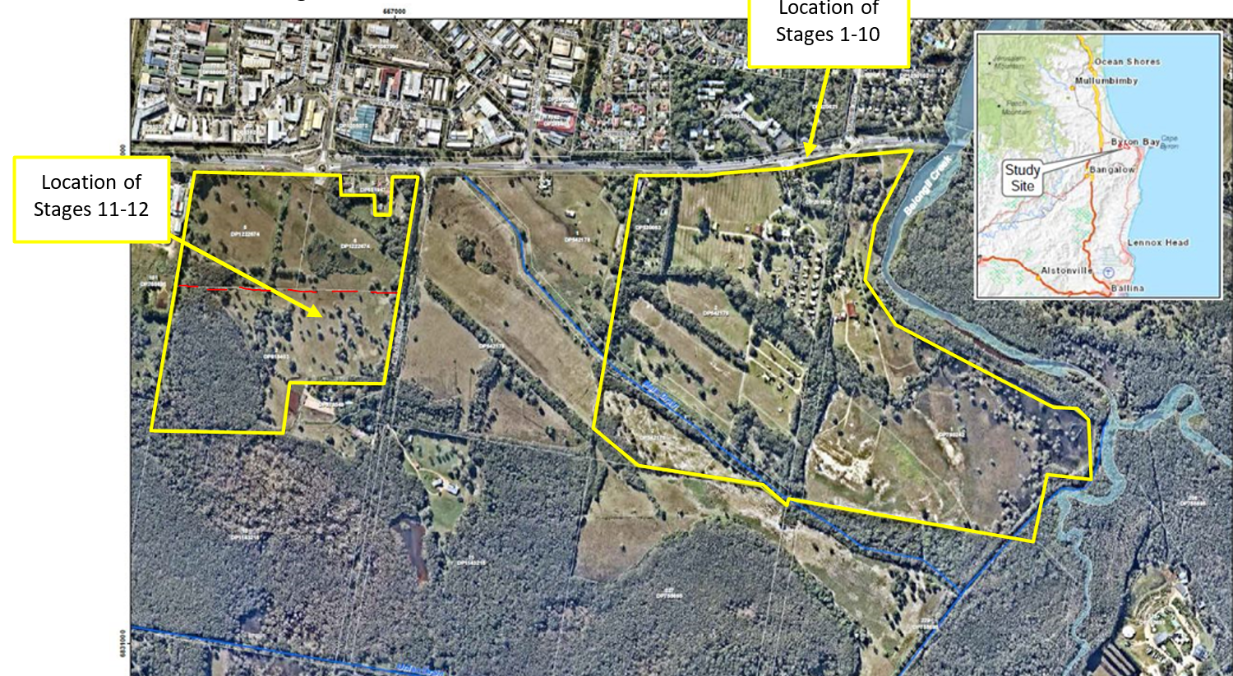

Figure 1 – The site (Site R & D) - area above the dashed red line at Stages 11 & 12 is common land with the Harvest Estate.

The eastern section of the site has a northern boundary to Ewingsdale Road, an eastern boundary along Belongil Creek, a southern boundary and western boundary bordering the “Harvest Estate” (approved under 10.2017.201.1 as amended by 10.2017.201.2 & 10.2017.201.3). The eastern section has a total area of 42.5ha.
The western section of the site is generally rhomboidal in shape. The western section has a northern boundary and eastern boundary to the Harvest Estate, a southern boundary against 46 and 50 Melaleuca Drive, Byron Bay, and a western boundary against 268, Ewingsdale Road, Byron Bay, and 66 Citriadora Drive, Ewingsdale. The western section has a total area of 11.64ha.

Combined, the eastern and western sections have a total area of 54.14ha. Site R & D is generally level with elevations ranging between 2m to 4m AHD.
The eastern portion of the site is presently occupied by the Belongil Fields camping ground and associated structures; two of the allotments within the eastern portion contain dwelling houses; and a significant area of coastal wetlands. The western portion of the site is vacant and includes a significant area of coastal wetlands.
The Harvest Estate
The eastern and western portions of the subject site (Site R & D) are largely separated by the “Harvest Estate” (approved under DA 10.2017.201.1 as amended). Stages 1 - 4 of the Harvest Estate development and subdivision align with stages 11 and 12 of the subject sie. However, Lot 105 DP 1297628 and Lot 2 DP 818403 are common to both Site R & D and the Harvest Estate. The land common to both is shown in Figure 2.
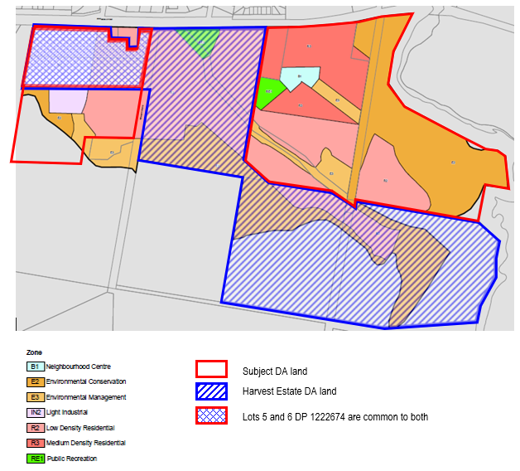

Figure 2 – Two subdivision consents - West Byron Urban Release Area (WBURA)

The development of the Harvest Estate has commenced, and early stages have been completed. Harvest is a residential subdivision comprising 149 residential lots. S4.56 modification 10.2017.2021.3, determined on 27/05/2024, consolidated the staging from seven stages to four stages. Justification for consolidation of staging was for cost efficiency and practical construction logistics; the same rationale for the proposed consolidation of staging within Site R&D under the subject s4.56 10.2017.661.3.

  - The Locality

The site is located approximately 2.5km west of the Byron Bay town centre with access to Ewingsdale Road along its northern frontage.
The site is located within the Byron LEP 2014 Urban Release Area Map and is known as the West Byron Urban Release Area (WBURA). The site, as delineated in the Urban Release Area Map is provided at Figure 3. The perimeter of Site R&D is roughly outlined in red highlight.
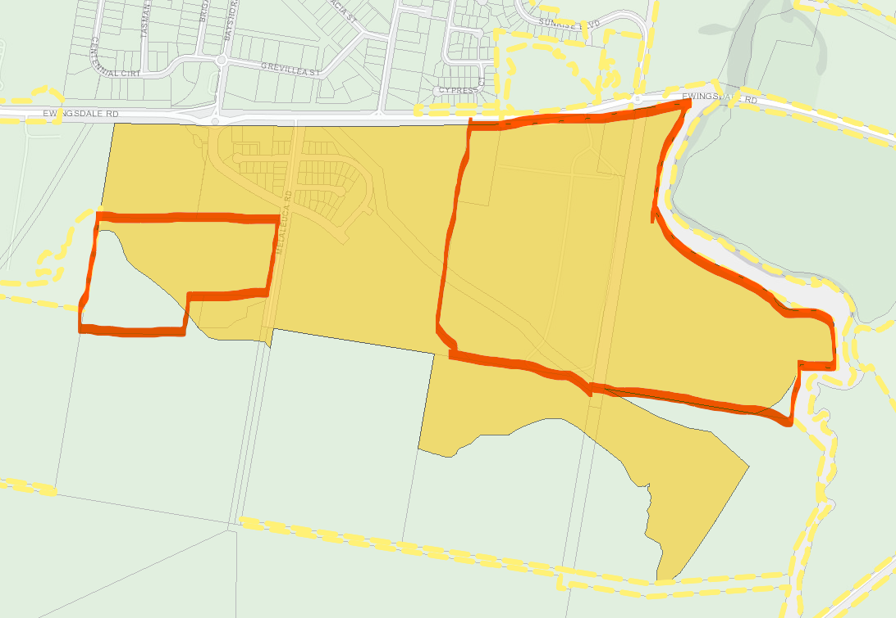

Figure 3 – West Byron Urban Release Area Map – Site R&D with approximate red outline

- THE PROPOSAL AND BACKGROUND

  - The Proposal

Development consent 10.2017.661.1 was issued on 8 March 2022 by the NSW Land and Environment Court to subdivide land in two separate areas, known as Site R&D, within the West Byron Urban Release Area (WBURA) and permits the creation of one hundred and sixty two (162) lots comprising one hundred and twenty seven (127) residential lots, twenty five (25) super lots, two (2) business lots, one (1) recreation lot, two (2) industrial lots and five (5) residue lots; over twelve (12) stages (13 Stages including Stage A - Environmental Works). Ten (10) of those stages are located on land in the eastern precinct of the development site, as shown in the extract of the approved staging plan at Figure 4

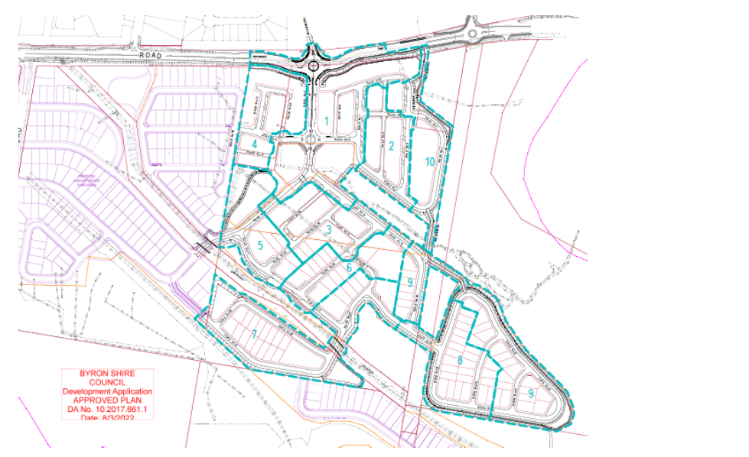

Figure 4 – Extract of the approved Staging Plan (Stages 1-10 eastern precinct)

The proposed modification seeks to reduce the number of stages within the eastern precinct from ten (10) to four (4). Refer to Figure 5 and Table 1 for detail. The proposed amended plans are located at Attachment B.
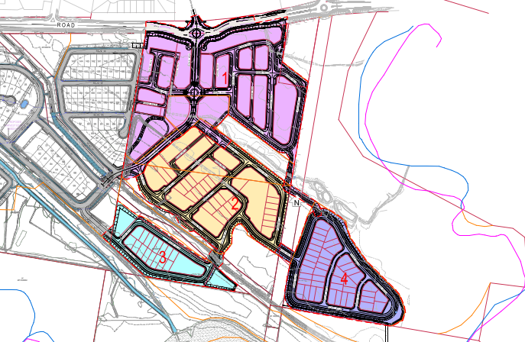
Figure 5 – Extract from Proposed Consolidated Staging Plan

Proposed Stage | Approved Stages | Land Zoning | No. Lots | Area
Stage 1 | Stages 1, 2, 4, 10 and part Stages 3, 5 & 9 | R3 | 12 residential super lots | 41,955m²
Stage 1 | Stages 1, 2, 4, 10 and part Stages 3, 5 & 9 | E1 | 2 local centre lots | 8,418m²
Stage 1 | Stages 1, 2, 4, 10 and part Stages 3, 5 & 9 | RE1 | 1 recreation lot | 9,113m²
Stage 2 | Stage 6 and part Stages 3, 5, 7 & 9 | R3 | 5 residential super lots | 12,811m²
Stage 2 | Stage 6 and part Stages 3, 5, 7 & 9 | R2 | 28 residential lots  4 residential super lots | 16,165m²  11,939m²
Stage 3 | Part Stage 7 | R2 | 16 residential lots  2 super lots  1 residential lot - bioretention | 8,057m²  5,815m²  3,028m²
Stage 4 | Stage 8 & part Stage 9 | R2 | 43 residential lots | 23,473m²
Table 1 – Proposed amended Staging

The proposed consolidation of staging also involves the consequential modification of relevant conditions of consent. Table 2 provides a brief outline of the proposed amended conditions. Amended conditions in full are located at Attachment A.

Condition No | Condition requirements | Change Proposed and reason
1 | Approved plans and documents | Delete some plans from the plan set and insert proposed new plans to reflect consolidated staging in eastern precinct from 10 stages to 4 stages. Red mark up used on some plans to:  - Confirm Stages 11 & 12 are not part of the consent;  - Confirm Lot 23 in Stage 3 is a bioretention lot;  - Request amended plan clearly labelling Community Title and Association Lots, consistent with condition 99A.
4B | Update engineering plans | Consequential amendment to plan reference in accordance with proposed new consolidated staging plans.
4D | Provision of amended subdivision plans | Consequential amendment to plan reference in accordance with proposed new consolidated staging plans.
4E | Provision of amended staging plans | Consequential amendment to plan reference in accordance with proposed new consolidated staging plans.  Amendment to Community Title and Association Lot plan to clearly delineate areas involved.
11 | Integrated approvals from other State Government Approval Bodies | Amend reference to the date of the existing RFS GTA’s to reflect amended GTA’s. New date 27/10/2025.
13A | Retirement of Biodiversity Credits | Consequential amendment to wording to reflect new stage numbering.
26 | Maximum disturbed area | Consolidated staging results in a larger area for each stage resulting in the ned to remove the 5ha disturbed area limit.
99A | Community Title Subdivision | Consequential amendment to plan reference in accordance with proposed new consolidated staging plans.
100 | Section 88E Instruments | Consequential amendment to wording to reflect new stage numbering.
110 | Certificate of Compliance – Water Management Act 2000 | Amended wording to confirm that a Certificate of Compliance under Section 307 of the Water Management Act 2000 is to be obtained for each stage of the subdivision.
116 | Compliance with bushfire conditions under Section 100B of the Rural Fires Act 1997 | Amend reference to the date of the existing GTA’s to reflect amended GTA’s. New date 27/10/2025.
119 | Emergency Access Bond | Consequential amendment to wording to reflect new stage numbering.
123 | Maintenance of landscaping on Ewingsdale Road | Consequential amendment to wording to reflect new stage numbering.
Table 2 – Proposed amended conditions of consent

Proposal rationale
The rationale for the proposed consolidation of stages is outlined in Table 3

Issue | Comment
Cost and construction efficiencies | Under the current staging regime, the approved development will take approximately 15.5 years for the completion of construction. The proposed staging consolidation will reduce the total development time to approximately 9 years. Increased economies of scale apply when a larger number of lots are developed at one time, thus increasing the likelihood that the development will proceed.
Minimise disturbance | Decrease the period of time heavy construction vehicles will need to access the site, therefore less disturbance for residents of dwellings constructed in early stages.
Housing delivery | Acceleration of the delivery of housing in WBURA
Preliminary works and monitoring | Environmental restoration works required by consent condition 13 were completed in early 2025, which is one of the requirements before the issuance of the first subdivision works certificate. No objection raised by Council’s Ecologist.
Ongoing monitoring | Various conditions of consent including but not limited to Conditions 7 (12-month monitoring period between each construction stage), 15, 17, 18, 20, 21, 43 & 46 provide for ongoing monitoring. No objection raised by Council’s Ecologist.
Stormwater and Groundwater | There are no proposed amendments to approved stormwater and groundwater management.
Traffic and Access | The development of the proposed Stage 1 will result in the construction of the full length of the approved arterial link road within the eastern precinct. This will bring forward the time for the delivery of a point of access to Ewingsdale Road from both Harvest Estate and Site R&D. Thus, good levels of site permeability will be achieved within a shorter time frame. This will benefit commuters, recreational users and emergency service vehicle access
Harvest Estate staging consolidation | Harvest Estate residential subdivision (149 residential lots) S4.56 modification 10.2017.2021.3, determined on 27/05/2024, consolidated the staging from seven stages to four stages. Justification for consolidation of staging was for cost efficiency and practical construction logistics.
Table 3 – Rationale for consolidation of staging

  - Background

The S4.56 modification application was lodged on 12 July 2024. A chronology of the modification application since lodgement is outlined in Table 4.

Table 4 - Chronology of the S4.56 Modification
Date | Event
11/07/2025 | S4.56 Modification submitted on NSW Planning Portal
29/07/2025 | S4.56 Modification lodged fees paid to Council
18/08/2025 | Referral to Bundjalung (Arakwal) & Tweed Byron LALC
25/08/2025 | External referrals:  - RFS – S100B Rural Fires Act 1997; S109 EP&A Regs 2021  - Transport for NSW – S2.122 SEPP (Transport and Infrastructure) 2021; S109 EP&A Regs 2021  - Department of Planning Housing and Infrastructure – S109 EP&A Regs 2021  - LEC – S107(4) EP&A Regs 2021
12/08/2025 to 08/09/2025 | Exhibition of the application – Two submissions received
18/19/2025 | RFI # 1 - Request regarding ET calculation
29/09/2025 | Applicant responds to RFI #1
09/10/2025 | RFI # 2 – Request regarding consequential amendments to other conditions; amended plans
13/10/2025 | Applicant responds to RFI # 2
23/10/2025 | RFI # 3 – Request regarding minor refinement to conditions and plan mark up
27/10/2025 | Applicant responds to RFI # 3 (email)

  - Site History

Application | Date | Outcome/Actions
10.2017.661.1 | 08/03/2022 | the judgment of Site R & D Pty Ltd v Byron Shire Council [2022] NSWLEC 1121 was published and DA approved.
 | 21/04/2022 | Conditions of consent filed
10.2017.661.2 | 11/12/2024 | S4.56 to Modify Subdivision Staging to Enable Stages 11 and 12 to proceed separately and non-sequentially with Stages 1 to 10. Approved by Northern Regional Planning Panel.

- STATUTORY CONSIDERATIONS

When determining a s4.56 modification of a court approved development application, the consent authority must take into consideration the matters outlined in Section 4.15(1) and Section 4.56 of the Environmental Planning and Assessment Act 1979 (‘EP&A Act’).

  - Section 4.56 of the EP&A Act 1979

Table 5 provides an assessment of the proposal against Section 4.56 of the EP&A Act 1979.

Table 5 – S4.56 EP&A Act 1979
Section | Assessment comments
4.56(1) | - The applicant is a person who is entitled to act on the consent which was issued by the Court.  - The development to which the consent as modified relates is substantially the same as the originally approved development.  - Public notification of the application in accordance with the EP&A Regulation 2021 and the Byron Community Participation Plan.  - Two submissions received. These are addressed elsewhere in this report.
4.56(1A) | Section 4.15(1) matters as are of relevance to the development the subject of the application are considered below.
4.56(1B) | Repealed.
4.56(1C) | The modification of a development consent in accordance with this section is taken not to be the granting of development consent under this Part, but a reference in this or any other Act to a development consent includes a reference to a development consent as so modified.  Noted.
4.56(2) | A copy of the notice of determination is required to be sent to each person who made a submission in respect of the application. Noted. Two submissions received.
4.56(3) | The deemed refusal provisions of the regulations are noted.
4.56(4) | Repealed.

  - Section 4.15(1) of the EP&A Act

Section 4.15(1) of the EP&A Act contains matters which the consent authority must take into consideration in determining a development application and modification applications pursuant to Section 4.56(1A), which are of relevance to the application.

These matters include the following, which are considered in detail below:

- the provisions of any environmental planning instrument, proposed instrument, development control plan, planning agreement and the regulations
(i) any environmental planning instrument, and
(ii) any proposed instrument that is or has been the subject of public consultation under this Act and that has been notified to the consent authority (unless the Planning Secretary has notified the consent authority that the making of the proposed instrument has been deferred indefinitely or has not been approved), and
(iii) any development control plan, and
(iiia) any planning agreement that has been entered into under section 7.4, or any draft planning agreement that a developer has offered to enter into under section 7.4, and
(iv) the regulations (to the extent that they prescribe matters for the purposes of this paragraph),
that apply to the land to which the development application relates,
- the likely impacts of that development, including environmental impacts on both the natural and built environments, and social and economic impacts in the locality,
- the suitability of the site for the development,
- any submissions made in accordance with this Act or the regulations,
- the public interest.

  - Environmental Planning Instruments, proposed instrument, development control plan, planning agreement and the regulations

The relevant environmental planning instruments, proposed instruments, development control plans, planning agreements and the matters for consideration under the Regulation are considered below.

A detailed consideration of the applicable environmental planning instruments was provided in the Commissioner’s Judgement on the original application (Site R & D Pty Ltd v Byron Shire Council [2022] NSWLEC 1121). The modification application does not raise any new issues in relation to the environmental planning instruments; proposed instruments; development control plans; planning agreements; and the regulations; applicable to the original development application, other than those listed below.

- Section 4.15(1)(a)(i) - Provisions of Environmental Planning Instruments

Relevant Environmental Planning Instruments
- State Environmental Planning (Biodiversity and Conservation) 2021
- State Environmental Planning Policy (Planning Systems) 2021
- State Environmental Planning Policy (Resilience and Hazards) 2021
- State Environmental Planning Policy (Transport and Infrastructure) 2021
- Byron Local Environmental Plan 2014

State Environmental Planning Policy considerations
EPI | Matters for Consideration | Comply
State Environmental Planning Policy (Biodiversity & Conservation) 2021 | Chapter 4: Koala Habitat Protection 2021  In relation to koala habitat protection, the subject site falls within the area of an approved Koala Plan of Management under the State Environmental Planning Policy (Biodiversity and Conservation). In accordance with clause 4.8 of the SEPP, the Byron Coast Comprehensive Koala Plan of Management (BCCKPoM) applies.  The management objectives for the West Byron Koala Management Precinct are “to consolidate the existing sub-populations and improve the exchange of genetic material with other KMPs to the north and south”.  The modification application does not seek to change the subdivision layout, extent of works, tree removal or retention or environmental restoration works. As such, a detailed review of the proposal against the BCCKPoM has not been carried out but is generally consistent with the BCCKPoM as the proposal as originally approved:  Council Ecologist has reviewed the proposed S4.56 modification and raises no issues of concern. | Yes
SEPP (Planning Systems) 2021 | Schedule 6 Regionally Significant Development  Clause 2 – Development that has an estimated development cost of more than $30M. The subdivision approved under DA 10.2017.661.1 has a development cost of $40M. Planning Panel is the consent authority. | Yes
SEPP (Resilience & Hazards) 2021 | Chapter 2: Coastal Management  - Section 2.8(1) - Development on land in proximity to coastal wetlands or littoral rainforest  (1) Development consent must not be granted to development on land identified as “proximity area for coastal wetlands” or “proximity area for littoral rainforest” on the Coastal Wetlands and Littoral Rainforests Area Map unless the consent authority is satisfied that the proposed development will not significantly impact on—  (a) the biophysical, hydrological or ecological integrity of the adjacent coastal wetland or littoral rainforest, or  (b) the quantity and quality of surface and ground water flows to and from the adjacent coastal wetland or littoral rainforest.  - Section 4.6 - Contamination and remediation to be considered in determining development application.  (1) A consent authority must not consent to the carrying out of any development on land unless—  (a) it has considered whether the land is contaminated, and  (b) if the land is contaminated, it is satisfied that the land is suitable in its contaminated state (or will be suitable, after remediation) for the purpose for which the development is proposed to be carried out, and  (c) if the land requires remediation to be made suitable for the purpose for which the development is proposed to be carried out, it is satisfied that the land will be remediated before the land is used for that purpose.  The proposed changes to the staging raises no issues under the SEPP (including previous SEPP 14 – Coastal Wetlands, SEPP 26 – Littoral Rainforest and SEPP 55 Remediation of Land) that have not been previously considered. | Yes
State Environmental Planning Policy (Transport and Infrastructure) 2021 | Section 2.122 – Traffic Generating Development  Schedule 3 - The S4.56 modification was referred to TfNSW as the subdivision site has access to a classified road (connection road less than 90m from classified road) and the number of allotments exceeds to 50 lot threshold.  TfNSW responded to the referral in correspondence date 25/08/2025 stating:  TfNSW has reviewed the information provided and understands the proposed modification to the approved development staging will not result in any significant impact on the nearby classified road network. | Yes

Byron Local Environmental Plan 2014

The Site R&D is located within the following zones under Byron LEP 2014. Refer to Table 6 for schedule of Land Zones.

BLEP 2014 Zone | Western portion (site of Stages 11 & 12) | Eastern portion  (Stages 1 - 4)
E4 General Industrial | 
R2 Low Density Residential | 
C2 Environmental Conservation | 
C3 Environmental Management | 
E1 Neighbourhood Centre
RE1 Public Recreation
R3 Medium Density Residential
Table 6 – Land Zones within Site R & D

An extract of LEP 2014 Land Zoning Map is provided at Figure 6.

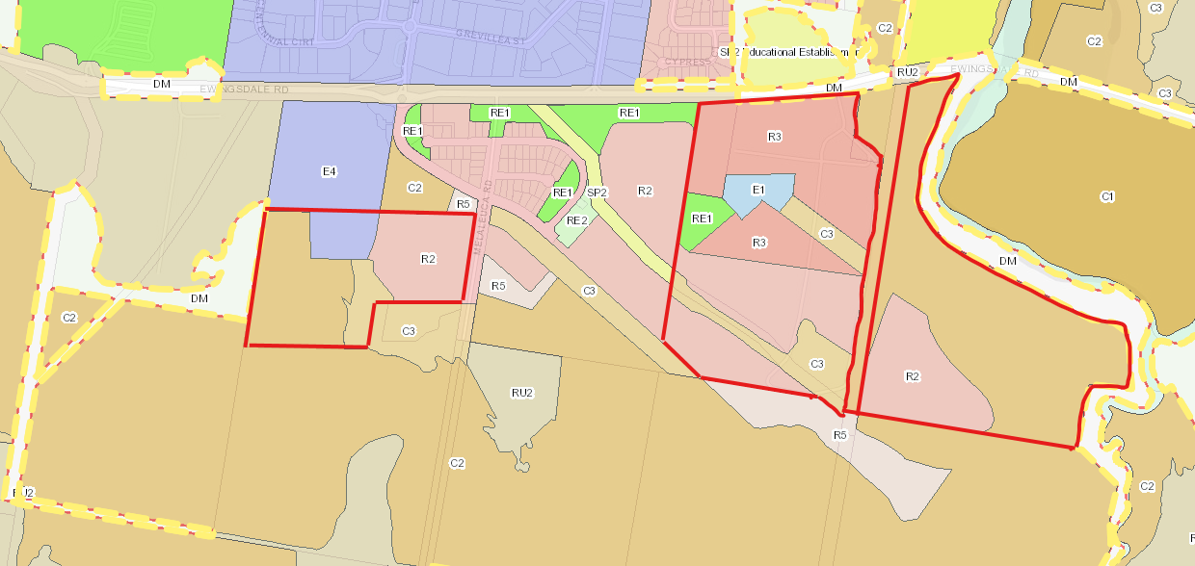
Figure 6 – Land Zoning Map LEP 2014

WBURA provisions of LEP 1988 were recently repealed and the area was transitioned to LEP 2014. The proposed S4.56 modification application does not raise any new issues in relation to the Byron LEP 2014. Relevant provisions are assessed in the compliance table below.

Byron LEP 2014 | Matters for Consideration | Comply
Clause 1.2 “Aims of Plan | Relevant aims:  - Is consistent with the principles of ecological sustainable development;  - Promotes and coordinates the orderly and economic use and development of land;  - Creates of an area that will provide for a diversity of housing choice;  - Protects and restores the natural environment and biodiversity of Byron | Yes
2.3 Zone Objectives | Must have regard to Zone objectives.  The proposed consolidation of staging has been assessed against the various zone objectives (refer to Table 3 and Figure 6 for zoning details). | Yes
  Zone | Objectives
  R2 | - To provide for the housing needs of the community within a low density residential environment.  - To enable other land uses that provide facilities or services to meet the day to day needs of residents.
  R3 | - To provide for the housing needs of the community within a medium density residential environment.  - To provide a variety of housing types within a medium density residential environment.  - To enable other land uses that provide facilities or services to meet the day to day needs of residents.
  E1 | - To provide a range of retail, business and community uses that serve the needs of people who live in, work in or visit the area.  - To encourage investment in local commercial development that generates employment opportunities and economic growth.  - To enable residential development that contributes to a vibrant and active local centre and is consistent with the Council’s strategic planning for residential development in the area.  - To encourage business, retail, community and other non-residential land uses on the ground floor of buildings.  - To maximise public transport patronage and encourage walking and cycling.
  RE1 | - To enable land to be used for public open space or recreational purposes.  - To provide a range of recreational settings and activities and compatible land uses.  - To protect and enhance the natural environment for recreational purposes.
Permissibility | ‘Subdivision’ of land is defined in section 6.2 of the EP&A Act 1979. Development standards relating to subdivision are provided in LEP 2014 Part 4. The proposed consolidation of stages is consistent with the LEP subdivision provisions. | Yes
Clause 4.1 Minimum subdivision lot size | The proposed consolidation of stages does not alter the lot area or configuration. Minimum lot size development standard for Zones R2 and R3 is 450m² and 200m² respectively. | Yes
4.1G Minimum lot size for certain residential accommodation – West Byron Bay site | N/A | N/A
4.1H Exceptions to minimum subdivision lot sizes for certain residential development – West Byron Bay site | N/A | N/A

- Section 4.15 (1)(a)(ii) - Provisions of any Proposed Instruments

There are no proposed instruments which have been the subject of public consultation under the EP&A Act, that are relevant to the proposal.

- Section 4.15(1)(a)(iii) - Provisions of any Development Control Plan

The proposed S4.56 modification application does not raise any new issues in relation to the Byron DCP 2014 other than those listed below.
Byron DCP 2014 | Matters for Consideration | Comply
Chapter E8 West Byron Urban Release Area | Chapter E8 of the DCP 2014 applies to land identified as the West Byron Bay Site which includes the subject land of this development application. | Yes
E8.10.1 Staging Plan | Many of the prescriptive measures for the staging plan can’t be met by the proposed development due to the subdivision being separated into an eastern and western development with separate designs and applications in contrast to the staging envisaged by DCP 2014 (e.g., roundabouts, Main Spine Road, Village Centre Precinct).  However, of relevance to this proposal to modify the size and number of stages is Prescriptive Measure 7 (E8.10.1):  Where more than 100 lots are to be released as part of a subdivision, a staging plan to be submitted with the development application breaking such land releases into stages of no more than 50 lots to enable the co-ordination and provision of necessary infrastructure and services.  All approved stages will deliver less than 50 lots. The amended Stage 4 is proposed to deliver the largest number of allotments at 43. The proposed consolidation of staging is consistent with Prescriptive Measure 7. The proposed consolidation of staging will ensure the orderly and coordinated development of the site. | Yes

Byron S7.11 Development Contributions Plan 2014

Development Contributions are payable under Byron S7.11 Development Contributions Plan 2014 in the current consent (10.2017.661.2). No variation to the contributions condition is required as the condition (Condition 113) is worded to provide flexibility for payment as a lump sum or proportional to any staging regime.

- Section 4.15(1)(a)(iiia) – Planning agreements under Section 7.4 of the EP&A Act

The following planning agreement/s has been entered into under Section 7.4 of the EP&A Act:

A voluntary planning agreement (VPA) 2013/8948 was executed on 21 October 2014 between the Minister for Planning and the Byron Bay West Landowners Association (the developer) on Lots described as 5/DP622736, 6/DP622736, 1/DP542178, 227/DP755695, 229/DP755695, 9/DP111821, 1/DP1166535, 1/DP201626, 2/DP542178, 1/DP780242, 2/DP818403 and 1/DP520063. The executed agreement facilitates the delivery of the developer’s contribution towards the provision of regional infrastructure and to ensure conservation land is appropriately rehabilitated and maintained.

The proposal is consistent with this Planning Agreement.

- Section 4.15(1)(a)(iv) - Provisions of Regulations

The proposed amendments raise no issues regarding the relevant regulations.

  - Section 4.15(1)(b) - Likely Impacts of Development

The likely impacts of that development, including environmental impacts on both the natural and built environments, and social and economic impacts in the locality must be considered. In this regard, potential impacts related to the proposal have been considered in response to SEPPs, LEP and DCP controls outlined above and the Key Issues section below.

Impact on: | Likely significant impact/s?
Natural environment | Proposed amendments raise no additional environmental issues which have not been previously considered
Built environment | The proposed amendments will not have a significantly adverse impact on the built environment of the locality.
Social Environment | The proposed amendments will not have a significant adverse social impact on the locality.
Economic impact | The proposal will not have a significant adverse economic impact on the locality, however, will enable a number of residential allotments to be released into the property market ahead of schedule, which are generally in short supply for this local government area.

  - Section 4.15(1)(c) - Suitability of the site

The proposed modification to consolidate existing stages 1 – 10 to 1 - 4 do not impact on the suitability of the site for the development as previously considered and approved by the LEC.

  - Section 4.15(1)(d) - Public Submissions

These submissions are considered in Section 5 of this report.

  - Section 4.15(1)(e) - Public interest

The proposal is unlikely to prejudice or compromise the public interest or create an undesirable precedent.

- REFERRALS AND SUBMISSIONS

  - Agency Referrals and Concurrence

The S4.56 Modification application has been referred to various agencies for as required by the EP&A Act and outlined below in Table 7.

Table 7 - Concurrence and Referrals to agencies
Agency | Concurrence/  referral trigger | Comments  (Issue, resolution, conditions) | Resolved
Concurrence Requirements (s4.13 of EP&A Act)
N/A
Referral/Consultation Agencies
NSW Land and Environment Court | DA 10.2017.661.1 was approved by the NSW LEC. The subject S4.56 modification required the notification of the LEC pursuant to S 107 of the EP&A Regulation 2021. | No response from the LEC required. | Yes
Integrated Development (S 4.46 of the EP&A Act)
RFS | Bush fire safety authority GTA’s issued under S100B - Rural Fires Act 1997 for DA 10.2017.661.1 (subdivision). The subject S4.56 also referred to NSW RFS under S100B. | The 4.56 modification application has been referred to the Rural Fire Service for an updated Bush Fire Safety Authority and general terms of approval (GTA). An updated Bush Fire Safety Authority has been issued and the consent to be amended accordingly. | Yes
TfNSW | Section 2.122 – Traffic Generating Development  Schedule 3 - The S4.56 modification was referred to TfNSW as the subdivision site has access to a classified road (connection road less than 90m from classified road) and the number of allotments exceeds to 50 lot threshold. | TfNSW responded to the referral in correspondence date 25/08/2025 stating:  TfNSW has reviewed the information provided and understands the proposed modification to the approved development staging will not result in any significant impact on the nearby classified road network. | Yes
Bundjalung (Arakwal) | Byron Shire Council Community Participation Plan 2019 | No objections raised | Yes
Tweed Byron LALC | Byron Shire Council Community Participation Plan 2019 | No objections raised | Yes

  - Council Officer Referrals

The development application has been referred to various Council officers for technical review as outlined Table 8.

Table 8 – Council Officer Referrals
Officer | Comments | Resolved
Development Engineering | No objections subject to conditions. | Yes
7.11 Contributions Officer | No variation to the contributions condition is required as the condition (Condition 113) is worded to provide flexibility for payment as a lump sum or proportional to any staging regime. | Yes
Water And Sewer ET Engineers | No Objection to the proposed amendments. | Yes
Ecologist | No issues of concern raised. | Yes

  - Community Consultation

The proposal was notified in accordance with the Council’s Community Participation Plan from 12 August 2025 until 8 September 2025.

The Council received a total of two identical submissions in objection. The issues raised in these submissions relate to the original court approved DA rather than the proposed s4.56 modification to consolidate staging. Notwithstanding, the aforementioned comments, the matters raised are considered in Table 9.

Table 9 - Community Submissions
Issue | No of submissions | Council Comments
Threats to native wildlife and habitat | 2 | The matter does not relate to the subject S4.56 modification.  The LEC considered this matter in its determination and the consent includes conditions relating to biodiversity conservation.
Indigenous creek and wetlands | 2 | The matter does not relate to the subject S4.56 modification.  The LEC considered this matter in its determination and the consent includes conditions relating to the protection and enhancement of water courses and wetlands.
Flooding risk | 2 | The matter does not relate to the subject S4.56 modification.  The LEC considered this matter in its determination and the consent. Most of the land involved in the proposed consolidated stages 1 – 4 is not identified as flood prone land. Note - The NSW 2023 Flood Risk Management Manual is the overall area subject to probable maximum flood (PMF).
Bushfire hazard | 2 | The NSW RFS have provided General Terms of Approval under S 100B of the Rural Fires Act 1997.
Road congestion and safety | 2 | TfNSW for NSW were consulted in accordance with S2.122 of SEPP (Transport and Infrastructure) 2021.  TfNSW responded to the referral in correspondence date 25/08/2025 stating:  TfNSW has reviewed the information provided and understands the proposed modification to the approved development staging will not result in any significant impact on the nearby classified road network.
Affordable housing and community workforce. Relocation of residents from existing Belongil Fields Caravan Park | 2 | The matter does not relate to the subject S4.56 modification.  The proposed development is limited to the consolidation of Staging involving a LEC approved subdivision.
Cultural and environmental values – destruction of Belongil Fields | 2 | The matter does not relate to the subject S4.56 modification.  The proposed development is limited to the consolidation of Staging involving a LEC approved subdivision.

- KEY ISSUES

The proposed S4.56 modification to reduce approved stages 1 – 10 to stages 1 - 4 will promote and coordinate the orderly and economic use of the land. The proposal will deliver cost and construction efficiencies, minimise the duration of construction disturbance for nearby residents, and accelerate the delivery of housing. There are no proposed changes to the number of lots or the configuration of the subdivision. All existing management plans and measures to control the development, including but not limited to biodiversity conservation; erosion and sediment control; pedestrian and traffic planning; ground water integrity; bushfire safety; still apply. There is no logical reason to oppose the proposed modification.

- CONCLUSION

This Section 4.56 modification application has been considered in accordance with the requirements of the EP&A Act 1979 and the Regulations as outlined in this report. The proposed modification is consistent with the relevant Environmental Planning Instruments and planning controls. It is considered that the application can be supported and is recommended for approval subject to the recommended draft conditions at Attachment A.

- RECOMMENDATION

That the Section 4.56 Modification Application 10.2017.661.3 to Section 4.56 to reduce 10 stages of the 13 stage subdivision, being Stages 1 – 10, to 4 stages, proposed Stages 1 – 4; and consequential amendments to conditions to reflect the new stage numbering be approved pursuant to Section 4.16(1)(a) or (b) of the Environmental Planning and Assessment Act 1979 subject to the draft conditions of consent attached to this report at Attachment A.

The following attachments are provided:
Attachment A: Draft Conditions of Consent
Attachment B: Amended Subdivision Plans
Attachment C: Existing Notice of Determination 10.2017.661.2

